Kadavar – s/t LP

Streetdate: 02.03.12

Vertrieb Cargo Deutschland / Sonic Rendevous (Benelux) / Green Hell Records

First off one thing is clear, it is impossible to overhear the Black Sabbath influence. Of course the impact of other great and important bands, such as Led Zeppelin, Hawkwind and Witchfinder General can also be heard in the music of this band. This can make you forget that you are actually listening to a contemporary trio from Berlin.  Reading this you could get the impression, that listening to KADAVAR's music could get boring quite fast, due to the fact that we've heard this kind of music before. The good thing about their music is that the sound is converted in such way that the audience notices that blood, sweat and tears have been shed during the process. Music like this can only be played on such high level if one has been through the rough shit that live brings with it sometimes.  As an audience we are automatically faced with long straight hair, minimum one mustache, a lot of rings on both hands, fur collars and flared trousers.  The Ludwig- Drum set sounds amazingly dry, well it is a Ludwig. Bass and Guitar stand on either side of the stage, building a panorama view, which is great fun over headphones. On the left you get Grease, on the right Fuzz, everything pounds and booms, there's the double space vocals. It's easy to be blown away. Superb.  The trio is a well attuned team that sing of Wizzards, Lucifer and of course Mountains. I don't quite understand how someone can be so deep into a matter but I like it. The guys names are Lindemann, Mammut, and TIger. I'm wishless!  For 70's hardrockfans this vinyl is a complete revelation, for all rockfans, that haven't dared to advance into the 70's stuff, this is a good field research. For me, this record is simply mega entertaining. A record that is stuffed with skill and know-how.You can't reinvent the wheel, but you can roll it!  This Charming Man strikes again.  Limited to 700 copies first press / 100 limited TCMR Mailorder only | 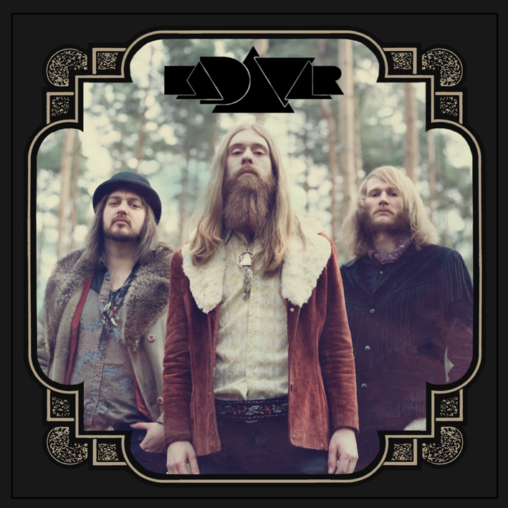  - 180 Gramm Vinyl mit MP3 Download  - firstpress limitiert auf 700 Stück  - 200 davon exklusive USA (Tee Pee)  - die ersten 100 Copies in col. Vinyl  Points of Interest:  - Cooperation mit Tee Pee Records USA (home of: u.a. Graveyard, Witch, Priestes, Ancestors)  - Debut Album der Berliner Band  - Sehr gute Szene-Resonanzen für Ihr Demo  - Mitglieder von NOEM, Ecke Schönhauser  - First Press Vinyl limitiert (700 Copies)  - im März, April und Mai auf ausgiebiger TOUR  - Presse von: Visions, Ox, Trust, Rock Hard, div. Onliner  For Fans of:  - 70er inspirierten Okkultrock  - Black Sabbath  - Hawkwind  - Witchfinder General
Presskit Download:  www.greenhell.de/thischarmingman/press/kadavar.rar  Web:  https://www.facebook.com/pages/kadavar  http://www.thischarmingmanrecords.com/index.php/bands/kadavar  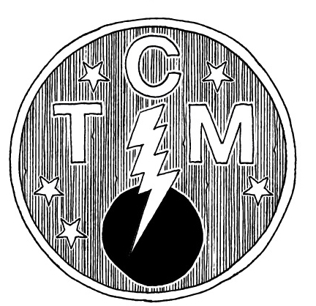  This Charming Man – Taking care of music  In the works:  Messer – Im Schwindel LP (Spring 2012)  Union Of Sleep / Black Sleep Of Kali split LP (Spring - 2012)  The Tidal Sleep – Debut LP | 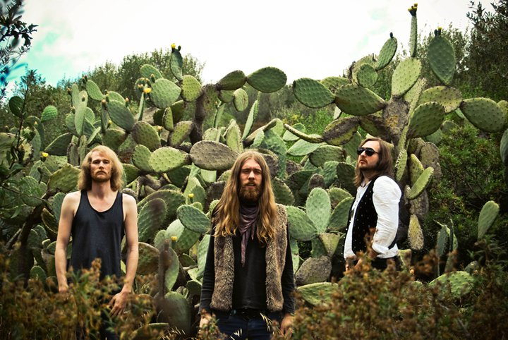  Tiger, Wolf Lindemann & Mammut  Tracklist:  All our thoughts  Black sun  Forgotten past  Goddess of dawn  Crature oft the demon  Purple sage  Spielzeit: 33,30 Minuten

